Practical 1
Module name: Login Page - Functional & UI Test Cases
Test case id: mahipal70
Webpage url: https://practice.expandtesting.com/secure

Scenario id : 01
Scenario :login with valid username passward
Test step

1. open login page
2.enter usernmae passward
3.click login

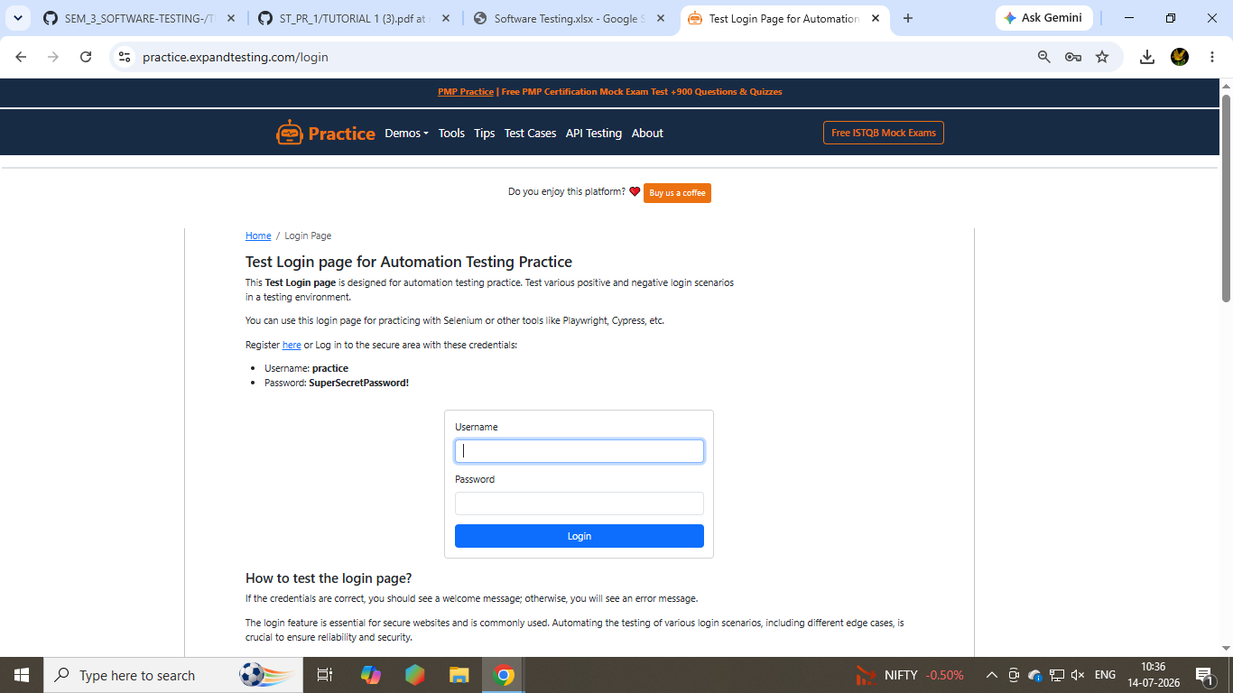
Scenario id :02
Scenario :invalid id passward
Test step
Retype the invalid id passward
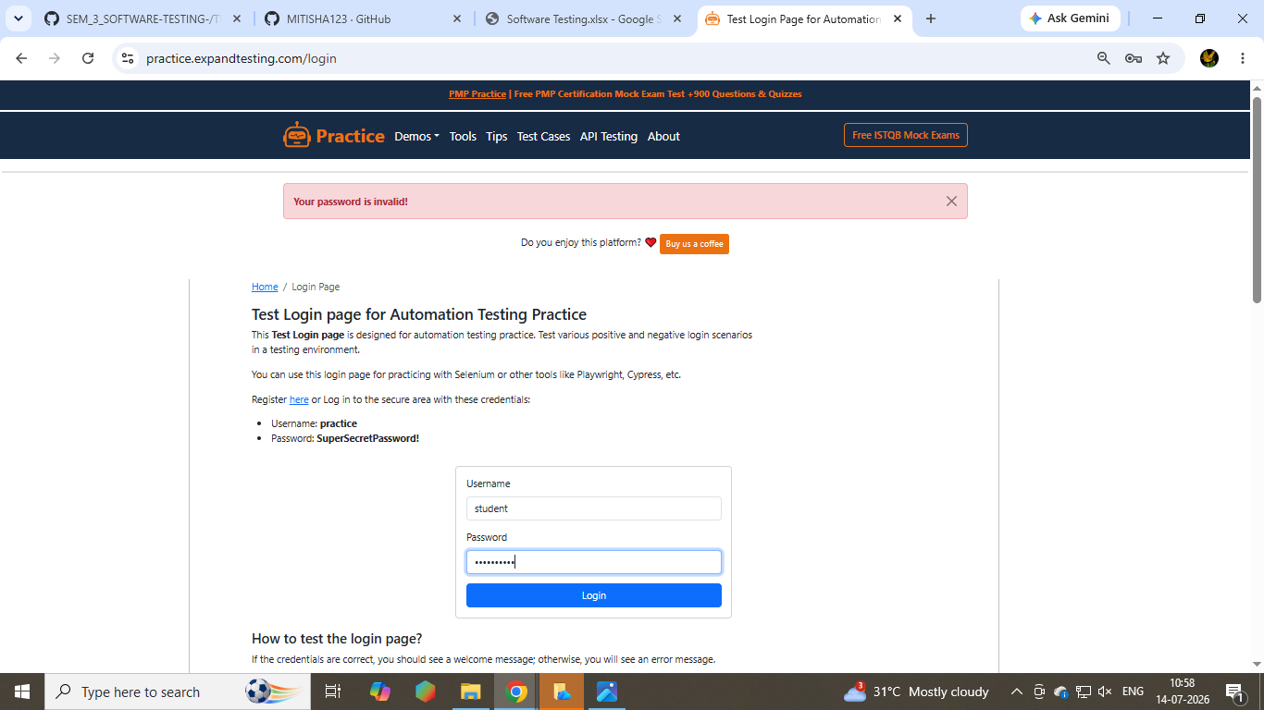
Scenario id :03
Scenario :acess the element of home page
Test steps
Go to the home link

